**Population**

**?**

**Sample**

(small group)

Gather Data

Explore Data

Make Inferences

A probability statement about the population based on the sample.

Ask a question   
about a **population**

(large group)

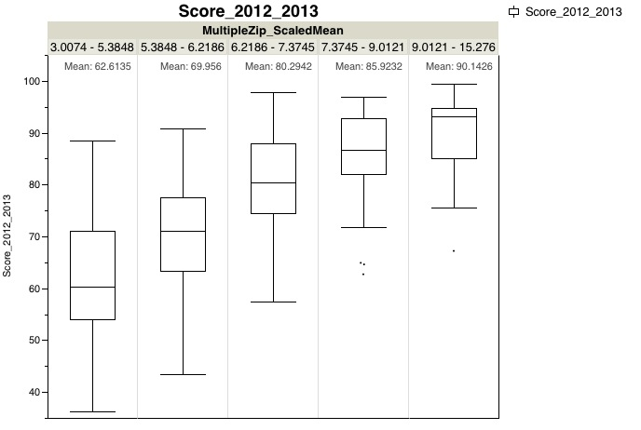

Graphing the mean, $\overline{x}$, of each possible sample of size 2 from the population of test grades would yield the following distribution:

SamplingDistribution.pdf

μ = 75.2

The mean grades that went into the above histograms follow:

|  |  |  |
| --- | --- | --- |
| Avg(74+83)= 78.5  Avg(74+71)= 72.5  Avg(74+77)= 75.5  Avg(74+78)= 76  Avg(74+71)= 72.5  Avg(74+75)= 74.5  Avg(74+80)= 77  Avg(74+74)= 74  Avg(74+69)= 71.5  Avg(83+71)= 77  Avg(83+77)= 80  Avg(83+78)= 80.5  Avg(83+71)= 77  Avg(83+75)= 79  Avg(83+80)= 81.5 | Avg(83+74)= 78.5  Avg(83+69)= 76  Avg(71+77)= 74  Avg(71+78)= 74.5  Avg(71+71)= 71  Avg(71+75)= 73  Avg(71+80)= 75.5  Avg(71+74)= 72.5  Avg(71+69)= 70  Avg(77+78)= 77.5  Avg(77+71)= 74  Avg(77+75)= 76  Avg(77+80)= 78.5  Avg(77+74)= 75.5  Avg(77+69)= 73 | Avg(78+71)= 74.5  Avg(78+75)= 76.5  Avg(78+80)= 79  Avg(78+74)= 76  Avg(78+69)= 73.5  Avg(71+75)= 73  Avg(71+80)= 75.5  Avg(71+74)= 72.5  Avg(71+69)= 70  Avg(75+80)= 77.5  Avg(75+74)= 74.5  Avg(75+69)= 72  Avg(80+74)= 77  Avg(80+69)= 74.5  Avg(74+69)= 71.5 |